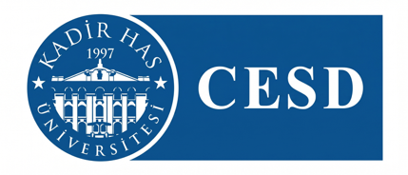
8th Graduate Student Conference on Energy and Sustainable Development
11 December 2026, Kadir Has University, Cibali Campus, Istanbul

Title of the Presentation

First Author Name & Surname, [University Name], [Department/Program], [City], [Country], [E-mail address].
Second Author Name & Surname, [University Name], [Department/Program], [City], [Country], [E-mail address].

Abstract

This template has been prepared to be used for writing the abstracts of the papers presented at the GS-CESD 2026-8th Graduate Student Conference on Energy and Sustainable Development at Kadir Has University. This template should be used without any modification. All abstracts should be written in English. The title of the abstract must be explanatory and as short as possible. The abstract should not extend to more than 1 page, including the abstract and keywords. Abstracts should not include figures, tables, or references.
Keywords: Energy, Sustainability, Development.

